**Presentation Title(Title in English)**

**The title should be the same as the title of the web registration.**

**Affiliation A1, Affiliation B2, Affiliation B(Present:****)3 ○Speakaer1, coauthor2, coauthor3**

**(Affiation and name in English)**

**Affiliations and authors' names should be the same as those in the web registration.**

**Student notation: Undergraduate (B), Master (M), Doctor (D), Postdoctoral (P)**

**\*Example: Name (M)1**

**【Introduction】**

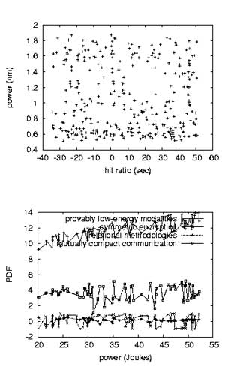

**・The manuscript should be one A4-size page.**

**・Font type and size are up to you, but it should not be too small. However, special fonts should not be used.**

**【Experimental Methods】**

**Columns are prohibited.**

**・Figures and tables may be any size, but should not be too small.**

**・Figures and tables should be captioned in either English or Japanese.**

**・Figures and tables should be numbered and explained in the text.**

**【Results】**

**When preparing your abstract, please keep the following in mind.**

・In principle, the research must be original and unpublished.

・Do not include content that could be considered military research.

・Do not include any content that is intended for advertising or commercial purposes.

・The contents must be free of research misconduct or inappropriate behavior.

・Do not include any content that is libelous or defamatory.

**【Conclusion】**

**・The abstract will be displayed in color.**

**・Please convert the file to a font-embedded PDF file and upload it.**

**・Uploaded files will be published as is, so please print them out before uploading to make sure they are displayed correctly and clearly.**

When preparing the manuscript, please delete the above preparation guidelines.